Joseph Cruel

SDV602 Assessement 2

SDV602 – Assessment 2

1. App Design and Documentation (LO 2,3)
   1. A brief description of the purpose of your application
   2. A set of storyboards depicting the working of the WHOLE application, including for example Login and Chat systems. Each storyboard is to include a table that details ALL interactions, inputs and outputs. (12 marks)

The purpose of my application is to display live data and have an interactive graphical display that will show charts to users of the application in real time. Each of the screens of this application is referred to Data Explorer Screen and it will allow the user of text input and mouse click. Giving in depth data analysis, it will support both text-based commands and or mouse interactions enabling users to explore data with flexibility. It also supports multiple users between other analysts. The application is aimed at a business or scientific analysts who need these tools to use it for data collaboration and making decisions based on the presented data.

## STORYBOARD

**User Registration**

The application will have a registration functionality, this would allow users to create an account in the application, once the user has created an account. They can log in using that information to see the data as an authenticated user.

The user must enter a username and password in the corresponding text boxes, once the user has filled in the text box. They can click register. Once done the user is now registered in the application and can log in.

The user must enter both the text boxes otherwise it will not let them register an account.

If the user enters an existing username, it will not let register as an account of the username already exists in the application.

**User Login**

The application will have a login functionality, this ensures that authorized users can access the sensitive data in the application, The users must log in the application before they can access the data being shown.

The user must enter their username and password that they have set in register. When that is done the user can click the login button and then will be able to access the lobby which has the data.

The user cannot enter a blank on either of the text boxes otherwise it will not log them in the application.

The user must enter the correct username and password to be able to access the data in the application.

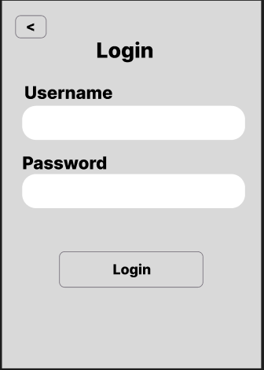

**Application Lobby**

Once the user is logged in the application, it will direct the user to the lobby. Inside the lobby will have 3 datas, the user can choose from set1, set2, and set 3.

The exit button will log the user out of the application.

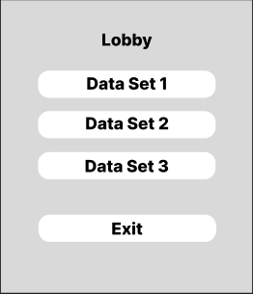

**Chat System**

The application will have a chat system which allows users to communicate to each other about the data presented in the application. This enables understanding from other user about the data and their input.

In the chat system, the user can see the messages sent by other users, and the user can see their own sent messages in the chat, the blank text box is where the user can add text messages. The send button will send that message in the chat log, it will show for all users.

Having no text inside the text box and press send will not send a blank message in the chat log.

**Data Explorer Screens**

**Set Data Source –**

The set data source, when clicked will show a list of data sources such as CSV files. The user can select from the list, and it will update the display depending on the data source chosen.

**Upload Data Source -**

The upload data source, when clicked will open file explorer and lets the user find a CSV file and select that file which will update the display which would reflect the uploaded data

**Pan -**

The Pan button allows the user to click and drag to move around the chart if the chart is large, which allows them to view the chart better. The user must click the Pan button which allows the chart to allowing panning.

**+/- -**

The Zoom (+/-) button allows the user to zoom in or zoom out of the chart, this allows the user to focus on details of the chart, or to get a bigger picture of the chart. The user must click the +/- button, clicking the button will change the size of the chart going from big to small, once it gets to max zoom, it will reset to a small size going bigger.

**Next –**

The Next button allows the user to view the next chart, once the user is satisfied with the analysis of a chart, they can click on the Next button to change into the next chart to analyze. For example if the user was looking at a line graph, they can click next to see a pie chart.

**Exit –**

The exit button allows the user to exit the data view. From here they will be taken to the lobby which they can choose another data to be viewed, or to exit out of the application. The user must click on the exit button to leave the data view.

**Data Explorer Screen 1**

**Data Explorer Screen 2**

**Data Explorer Screen 3**

1. Implement tests scripts that runs three DESs (LO 2,3)
   1. Six marks per screen.
   2. Each DES:

• accepts correct input and displays correct information (6 marks)

• displays a place holder for the chart (6 marks)

• provides navigation to other DESs, must include a top command interface

to display them all (6 marks)

1. Coding practices (LO2)

For the coding practice I am looking at the PEP 8 Style Guide

**Imports** – The imports are meant to be on separate line, they are put on the top part of the file. They are sorted in three sections (Standard library imports, Related third-party imports and Local application/library specific imports)



**Functions and Variable names** – in the guide, function names should be lowercase, the spaces are instead represented as underscores “_” , which is meant for readability. Variable names also follow this rule.

**Indentation** – In python using a 4 space per indentation level through the code. PEP 8 ruling is that 4 space should be used for each level of indentation

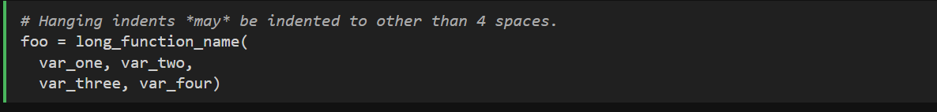

**Whitespaces** – avoiding whitespace trailing due to it being invisible. Adding whitespace around the operators such as, ( =, + , % ) not using more than one space and having the same amount on both sides. It allows for readability of the code

**Line Length** – in PEP 8 the rule is that the line length limit is a max of 79 characters, for flowing long block it should be around 72 characters.